SOCIAL WORKER DEGREE APPRENTICESHIP

Mentor Guide

The origin of the word mentor lies in Homer’s Odyssey. Mentor was given the task of caring for Telemachus while his father Odysseus, was away. The ‘mentor’ was designed to help Telemachus with his own self-development and was intended to be a role model, a guide and a supportive friend.

Contents
1. Introduction 3
2. The Role of the Mentor 3
3. Example Timeline of Mentor Activity 4
0-5 Months 5
6-18 Months 5
18 -24 Months 5
24-30 Months 5
4. Progress Reviews 7
4.1 What can I do to prepare for a review? 7
4.2 What is my role in a review? 7
4.3 What can I do between reviews? 8
5. Resources for Mentors 8
5.1 Social Work Portfolio 8
5.2 Action Plan Template 1 8
5.3 Action Plan Template 2 9
5.4 Action Plan Template 3 10
5.5 Three Stage Theory Framework Template 10
5.6 Kolb’s learning cycle 11
5.7 David Clutterbuck presents a light-hearted article entitled:- 13
6. Engaging with the E-portfolio 14
7. Employer Resources Pages 14
8. Key Contacts 15
Appendix 1 – Example EPA Gateway Form 16

1. Introduction

The Social Worker Degree Apprenticeship is a practice-based route to full registration as a Social Worker with Social Work England. Apprenticeships are a collaboration between training providers and employers to create a holistic learning environment that transcends traditional educational boundaries.
The apprenticeship is built around the Knowledge, Skills and Behaviours developed through engagement with the bespoke BA (hons) Social Work programme that delivers the fundamental requirements to apprentices to complete their professional development.
However, apprentices will need to continue their development away from university-directed learning and employers, through an allocated mentor, are vital in progressing work-based competencies. We want to create a learning culture that develops curious, analytical, and reflective practitioners who apply learning directly to their social work practice.
The information contained in this guide will provide you with a framework for how you can create the right conditions for apprentices to develop as competent professionals that espouse your values and are ready to take on a new role in your organisation. It is designed for reference and can be used on its own or to complement any employer-centred approaches.
The guide will also outline some of the formal mechanisms for documenting apprentices' progress, the systems that are used and describe the support available to you. This guide is intended to complement the apprentice’s programme handbook that describes the philosophy, delivery and assessment of the programme.

2. The Role of the Mentor

All apprentices should be allocated a mentor by their employer. The mentor will be knowledgeable about social work and is an important source of learning and support for apprentices as they progress through the programme.
Mentors will appraise the development of an apprentice’s knowledge, skills and behaviours against the statements contained with the apprenticeship standard. They will provide apprentices with opportunities (sometimes in Community of Practice groups and sometimes individually) to reflect on their practice, growth and development.
Mentors will support apprentices in developing and applying professional knowledge and skills, including analysis and decision-making, use of professional authority and ethical practice. It is not the role of a mentor to observe or advise apprentices on specific actions in their daily work, unless they are also the line manager.
Working with the University’s Enhanced Skills Coach, the mentor is the employer’s key stakeholder in guiding the programme’s work-based development. They will attend three-way meetings, three times each year, to discuss apprentices’ evidence recorded against the apprenticeship standard and other key progression measures.
However, outside of formal review meetings it is expected that there will be regular contact between a mentor and their apprentice, through 1 to 1 sessions, observations, feedback discussions and shadowing.
Mentors also play a key role in supporting apprentices to develop their portfolio, signing off reflections and completing direct observations. At the end of the apprenticeship they will also produce a holistic report to document the apprentices Knowledge, Skills and Behaviours development, and a three point action plan for their Assessed and Supported Year in Employment or post-qualifying year.
What kind of mentor are you?

1. Directive …………………………………………………….Non-Directive

2. Cognitive…………………………………………………..Emotional

3. Active ………………………………………………………Passive

The first indicates the extent to which you tell/ instruct/ show the mentee what to do. Directive would be teacher or instructor, non-directive being helper.
The second is cognitive. Do you see yourself as expert imparting knowledge and information or are you attending to the mentee’s development as counsellor or even friend.
The third is whether you see yourself as active, is your role to discipline and assess. Are you more of a colleague or facilitator.
Visit this discussion with your mentees and it may well help both of you.

3. Example Timeline of Mentor Activity

Mentors will play an active role from the start of the apprenticeship, helping to create links between social work theory and practice. The timeline below is an example of how you may wish to structure the activity that is required of a social worker apprentice mentor.

0-5 Months
During the first five months of the programme, the apprenticeship is fast-paced and there are four assessments to be completed. We would therefore suggest that this is a time for scoping and planning for future work-based learning to begin. During this time, you will:
- Organise an Initial meeting with your mentee
- Schedule in regular 1:1s (every 4-6 weeks)
- Scope contrasted work-based setting opportunities
  - Remember if the apprentice will not gain experience of statutory social work in their substantive role this must be incorporated into their contrasted learning opportunity.
- Support the apprentice to reflect upon a period shadowing a social worker.

6-18 Months
As apprentices start Level 5, there is more of a focus on work-based learning and developing key practice competencies. This is facilitated via the Aspire 1 Unit and the portfolio. During this time, you will:
- Complete two direct observations of practice
- Complete regular 1:1s (every 4-6 weeks)
- Ensure work experience within a statutory environment is planned
- Review the apprentice’s practice portfolio and reflections on first work-based setting

18 -24 Months
As apprentices start Level 6, they will be introduced to End Point Assessment concepts and should be supported to finalise their knowledge, Skills and behaviours development. In order to advance to through the End Point Assessment gateway, their employer must confirm that they are ready to undertake the final unit and that they have completed the portfolio. As part of this process, there will be a final review with the University Skills Coach and the Apprenticeship Gateway form will be completed (Appendix 1).
During this time, you will:
- Complete a further observation of practice
- Continue regular 1:1s (every 4-6 weeks)
- Review of practice portfolio and reflections on second work-based setting

24-30 Months
The final six months of the programme focuses on completing a large 60 credit unit that gives apprentices the opportunity to demonstrate their learning from the first two years of the programme, evidencing their readiness for practice.
The Applying Law, Safeguarding and Interdisciplinary Practice unit requires apprentices to:
- Write a critical case study of a practice case (must be a recent case)
- A presentation to a panel including a representative from the employer experts by experience and a University representative.

Mentor support will be very important during this period. Mentors are responsible for signing off an apprentice’s readiness for practice, confirming that they are confident they will have met the apprenticeship’s Knowledge, Skill and Behaviours. This is done via the apprentice’s practice portfolio, where a 500 word summary report is required. The template for this report can be found in the portfolio template – available at www.mmu.ac.uk/study/apprenticeships/resources/social-worker
Completion of the portfolio, forms one part of the End Point Assessment Gateway requirements, which must all be completed by before the final university exam board takes place on completion of the last unit. This is illustrated below.

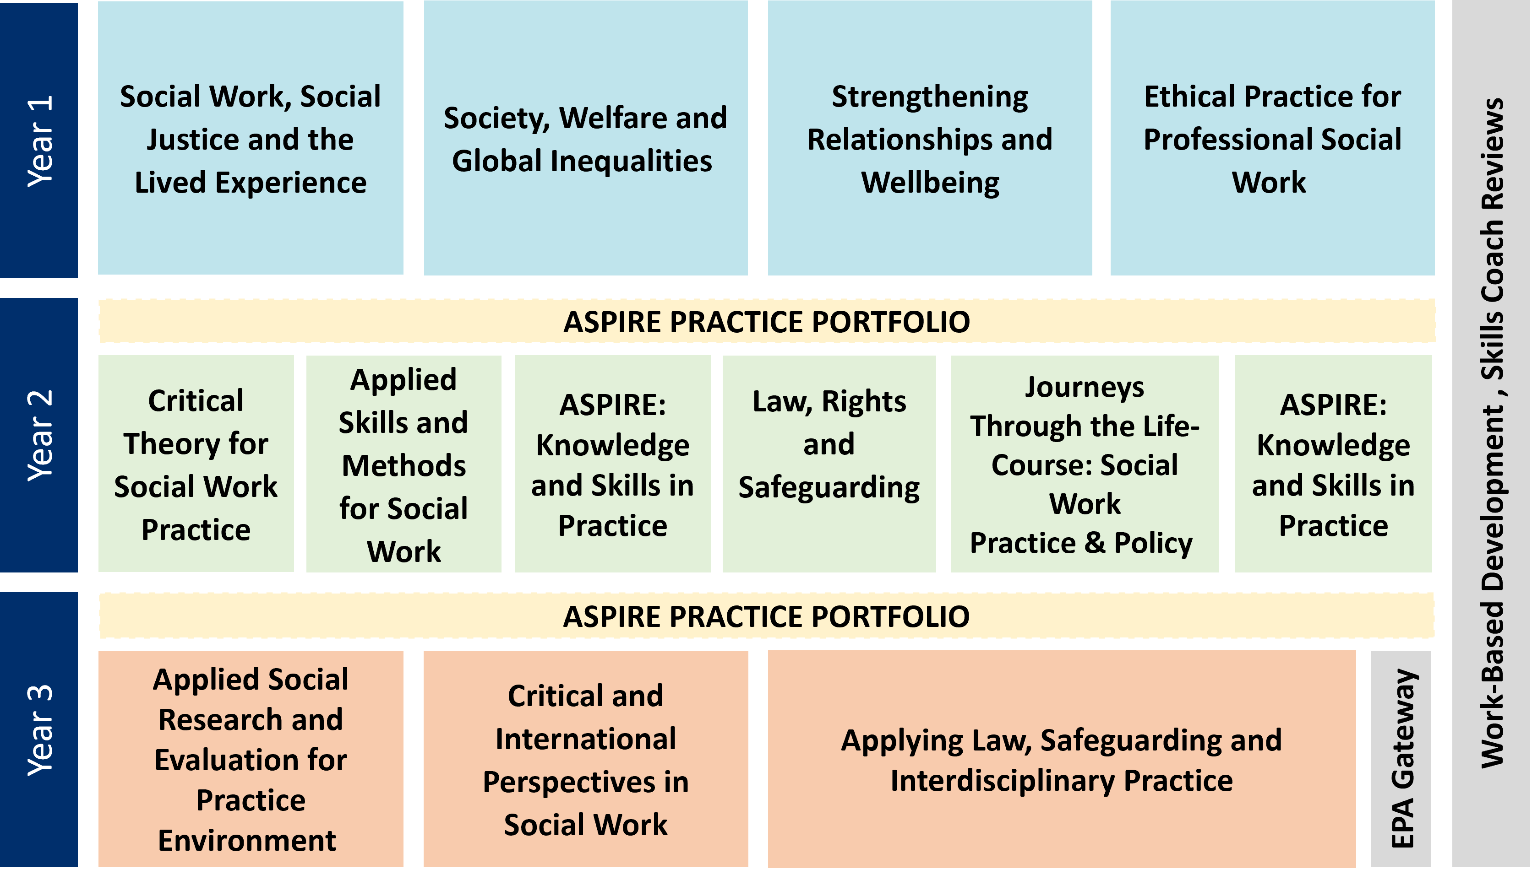
The full list of End Point Assessment criteria that must be met prior to completing the programme are:
- University and Employer agree that the apprentice has met the Knowledge, Skills and Behaviours of the apprenticeship standard
- Provide evidence of Level 2 (GCSE) Maths and English
- Successfully completed supervised practice in at least two contrasting settings, one statutory, and know why they took place
- Completed and documented 200 days in supervised practice learning
- Completed all required modules from an Social Work England approved qualification
A full list of requirements and an example of the form required to be signed off, is at the end of this guide – Appendix one.

4. Progress Reviews

As a workplace mentor, you will attend tripartite reviews with your apprentice and a representative of the University – the Skills Coach.
Tripartite reviews are typically held four times per year and are a formal appraisal of progress. These meetings are also used to look ahead and set SMART targets to push an apprentice to develop in areas of an identified need. They should be informed, not only by the information provided via the university’s e-portfolio, but also by feedback from the apprentice and mentors ongoing work together.
We will also discuss the portfolio (more information under resources section 5.1 below) at every review and set actions.
Reviews present the opportunity to discuss challenges about meeting any particular aspects of the apprenticeship standard and find solutions for achieving everything required. The Skills Coach is able to assist with any request for support, and where appropriate facilitate specialist help by sign posting to the appropriate University department.
Mentors should make sure they are familiar with their university contacts and should get in touch with any concerns or queries. Reviews typically last around one hour and are documented via a review report that is prepared by the Skills coach and shared with everyone in attendance.

4.1 What can I do to prepare for a review?

While the skills coach will play an active role in the review, this is the opportunity for you and the apprentice to review what you have achieved or challenges that have been identified since the last review took place. Inevitably, this will require preparation and you may find it useful to schedule a short meeting to prepare.
You may also find it useful to revisit your apprentice’s portfolio and the record of the last review to evaluate progress against the targets identified.

4.2 What is my role in a review?

During a review the skills coach will be completing a review template which will guide the discussion. It will typically begin by reviewing agreed goals and your feedback in terms of highlighting any achievements or challenges will be important.
It is possible that you will have a different perspective to your apprentice, which could help to provide possible solutions and identify new development opportunities. This may involve agreeing to advocate for the apprentice to undertake duties outside their normal areas of responsibility or in parts of the organisation that may be new to them.

4.3 What can I do between reviews?
Reviews are a vital component of the apprenticeship. For them to be effective the discussions and outcomes of reviews should be monitored through regular reflective supervision between mentor and apprentice. This will allow you to also demonstrate progress by the time of the next review meeting, as well as helping your apprentice to link theory to practice and evidence they have met any relevant BKSBs.
While some of the actions between reviews will be independently agreed developmental objectives, particular actions may also be suggested by the skills coach that may involve utilising some of the resources in this guide and completing elements of the portfolio.

5. Resources for Mentors

5.1 Social Work Portfolio

A key element of the apprenticeship and an important function of the mentor is to support the creation of the practice portfolio. The document below contains a variety of templates that must be completed by the apprentice and mentor. Completion of the portfolio is a requirement and provides an important record of evidence of practice learning. The goal is to ensure that apprentices can demonstrate they are applying the knowledge, skills and behaviours in the apprenticeship standard to the level required. This would be equivalent to end of final placement level. As 80% of the apprentices’ time is spent at work it is expected that they will work on the content incrementally with the majority of work being undertaken in Years 2 and 3. Progress will be monitored as part of the review process with their skills coach.
You can access the latest version of the portfolio document on www.mmu.ac.uk/study/apprenticeships/resources/social-worker

5.2 Action Plan Template 1

Area for Development (linked to Apprenticeship Standard) | Learning and Development needs | What do I need to do next? | What resources do I need? | Who can help me? | What is my timescale?

5.3 Action Plan Template 2

Knowledge to gain/skill to develop/ | Proof (how will I know when I have done it?) | Development Activities | Potential Help | Target for Compltion

5.4 Action Plan Template 3

Objectives (linked to Apprenticeship Standards)  What do I want to be able to do or do better? | Success criteria  How will I recognise success?  How will I review and measure my improvement? | Actions  What methods will I use to achieve my learning objectives? | Implementation  How will I practice and apply what I have learned?

5.5 Three Stage Theory Framework Template

You may wish to refer to the Developing Together Social Work Teaching Partnership website for guidance on how to effectively use the KIT model.
A blank version of the diagram is shown below and you may wish to use this with your apprentice.

5.6 Kolb’s learning cycle

We need to understand learning styles so that, if we are mentoring others, we set out our stall in a way that is conducive to the individual(s) and their abilities to absorb information.
If we get it wrong, it can impact the learner in a detrimental way.
For example, if we learn by seeing something being carried out and then reflecting on what we have seen, that needs to be implemented by our coach or mentor.
The learning cycle that David Kolb analysed in his model published in 1984 basically involves four stages, namely: concrete learning, reflective observation, abstract conceptualization and active experimentation.

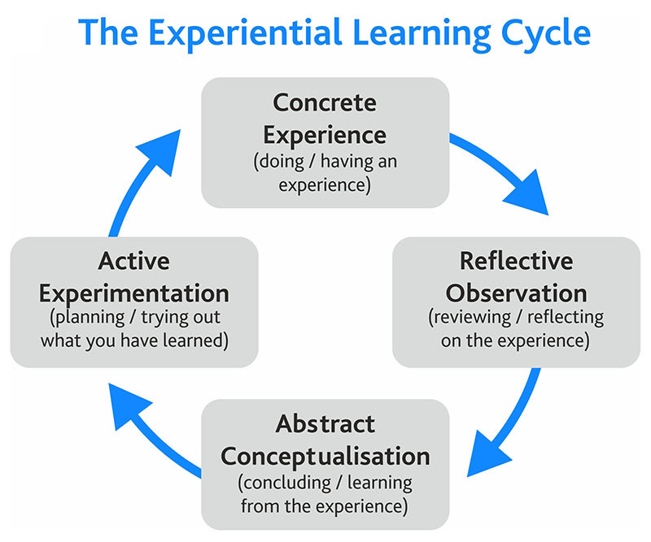

What do these stages involve?
Why are they important for us to analyse?
Well, the first stage is concrete learning or concrete experience, where the learner encounters a new experience or reinterprets an existing experience.
This could be where the learner is exposed to a new task or a new way of carrying out a project, in a way they haven’t seen before.
This is followed by the next stage, reflective observation, where the learner reflects on the experience on a personal basis.
For many people, this is where the metamorphosis from seeing and doing to reflecting can embed the learning into real-time absorption of materials and methodology.
It could be where a person is shown how to accomplish a goal and then looks at how it could be applied in differing circumstances.
Following reflective observation is abstract conceptualisation, where learners form new ideas, or modify current abstract ideas, based on the reflections that arise from the reflective observation stage.
They now have the chance to see how the ideas learned previously can be applied in their real world. The concepts they see can be altered by the results they have seen obtained in observing the ideas formulated in previous stages.
Then, there’s the active experimentation stage.
This is where the learner applies the new ideas to her surroundings to see if there are any modifications in the next appearance of the experience.
By actively experimenting with the whole concept of visible action, we learn to associate what we have experienced with new ideas and innovations.
So, what’s the application for us if we are mentoring others?
Well, we can review these concepts developed by David Kolb and initiate new ideas in learning sessions in these three ways:
1) It will help us to target more specific learning sessions for people we are working with
2) It will help us design training and coaching exercises that link up with the specific way our learners take in information
3) It will help us personalise any learning intervention for people in line with the four stages listed above.
By providing different learning initiatives, we increase the chances of the person assimilating the information effectively and helping them create ideas that may have been off their radar if the learning had been in a different style.
Why not have a discussion about the above with your mentee and between you try and work out both their learning style and yours?

5.7 David Clutterbuck presents a light-hearted article entitled:-

“Twelve habits of a Toxic Mentor”

1. Start from the point of view that you – from your vast experience and broader perspective – know better than the mentee what’s in his or her interest.

2. Be determined to share your wisdom with them – whether they want it or not, remind them frequently how much they still have to learn.

3. Decide what you and the mentee will talk about and when; change dates and themes frequently to prevent complacency sneaking in.

4. Do most of the talking; check frequently that they are paying attention.

5. Make sure they understand how trivial their concerns are compared to the weighty issues you have to deal with.

6. Remind the mentee how fortunate s/he is to have your undivided attention.

7. Neither show nor admit any personal weaknesses; expect to be their role model in all aspects of career development and personal values.

8. Never ask them what they should expect of you – how would they know anyway?

9. Demonstrate how important and well connected you are by sharing confidential information they don’t need (or want) to know.

10. Discourage any signs of levity or humour – this is a serious business and should be treated as such.

11. Take them to task when they don’t follow your advice.

12. Never, never admit that this could be a learning experience for you, too.

6. Engaging with the E-portfolio

The best place to keep a record of your work with your apprentice is on the university’s e-portfolio system. The e-portfolio is managed by the apprentice and it is a key part of their apprenticeship to take responsibility for creating a record of their development that reflects their competencies.
You will be given viewer access to your apprentices e-portfolio, so you can observe their progress through the learning and contact hours, reviews and self-appraisal through skills scans.
The e-portfolio is only as useful as the content that is contained within it, so its regular use will help to ensure that it develops into an accurate record that you can use to guide discussions about progress.
You will be introduced to the e-portfolio at the University’s Manager and Mentor session which is typically scheduled for the beginning of the programme. Information about the dates of next sessions and resources are available on our employer resources page.
Should you become a mentor later in the programme or need additional support please contact us.
An important function of the ePortfolio is to record an apprentices engagement with the programme, which must add up to a minimum of 6 hours per week of their contracted working hours.

7. Employer Resources Pages

You can find a range of additional resources and information on the University’s employer resources page for the Social Worker Degree Apprenticeship.
These pages contain timetables, programme handbooks, e-portfolio guidance and explanations of concepts such as the off-the-job entitlement.
You can access the page below:
www.mmu.ac.uk/study/apprenticeships/resources/social-worker

8. Key Contacts

We know that the role of mentor may not be one with which you are familiar and if you are it may be that you have not mentored apprentices before. We are here to support you in any way that we can and contact us with any questions, queries or concerns you may have.

Pauline Black | Programme Leader | p.black@mmu.ac.uk
Briony Spedding | Senior Lecturer | B.Spedding@mmu.ac.uk
Sonia D’Andreta | Skills Coach | Sonia.DAndreta@mmu.ac.uk
Glyn Slack | Skills Coach | J.Bowden-King@mmu.ac.uk
Gary Law | Skills Coach | d.barron@mmu.ac.uk
Claire Parry | Programme Manager | C.Parry@mmu.ac.uk
Apprenticeship Enquiries | Apprenticeship Unit | apprenticeships@mmu.ac.uk

Appendix 1 – Example EPA Gateway Form

Example End-Point Assessment Gateway Declaration Form
Please complete this form to confirm that all parties are satisfied that the apprentice has met the gateway requirements and can be put forward for end-point assessment (EPA)
Apprenticeship Standard: | Social Worker (Integrated Degree)
Apprentice Name:
Apprentice ULN:
Employer Name:
Start Date:
End Date:

Employer and University declaration

I confirm the above-named apprentice has met the following requirements.

Met the knowledge, skills and behaviours (KSBs)
Employer and Social Work England Approved Education Provider, Manchester Metropolitan University, are satisfied the apprentice has consistently demonstrated they meet the KSBs of the occupational standard.
Has been employed throughout the duration of the apprenticeship
Has evidence of achievement of Maths and English qualification at a minimum of level 2
Successfully completed supervised practice in at least two contrasting settings, one with a focus on statutory work, and knows why these were completed.
Successfully completed and documented 200 days in supervised practice learning. Up to 30 of these days can be allocated to apprentices developing their skills for practice, also known as ‘skills days’.
Achieved all required modules (360 credits) from the BSc (Hons) degree in Social Work
Achieved all required modules, taking into account any recognition of prior learning (RPL) of the Social Worker qualification but before the Approved Education Provider’s examination board.
Met the Off-the-job requirement.

Signed on behalf of the employer: |  | Employer Date of Signing:
Signed on behalf of the University: |  | University Date of Signing:

Apprentice declaration:
I confirm that I have gone through a gateway process to check that I am eligible for End Point Assessment.

I give Manchester Met permission to apply to the ESFA and the Institute for Apprenticeships for the apprenticeship certificate on my behalf when I complete End Point Assessment.

Apprentice Signature: |  | Apprentice Date of Signing:

