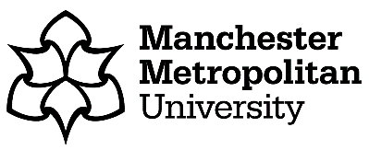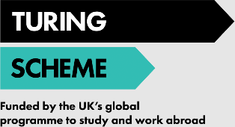

**Turing Scheme – Application for Funding**

The [Turing Scheme](https://www.turing-scheme.org.uk/about/information-for-participants/) is the UK government’s flagship student mobility funding programme that provides funding to UK organisations to unlock life-changing experiences across the world for their students.

Manchester Metropolitan University has secured Turing Scheme funding to support Manchester Met students studying abroad in 2021-22 via the student exchange programme.

**Funding and Financial Support**

The Turing Scheme provides funding towards the general cost of living abroad in the form of mobility grants that are calculated according to set grant rates in accordance with the length of the mobility period abroad.

Click on this link for the full [Turing Scheme terms and conditions of funding](https://www.mmu.ac.uk/study/international/study-abroad/offer-holders/study-abroad-turing-scheme-funded). This includes information on how the scheme works, how grants are calculated and how your personal information is used within the Turing Scheme.

In order to be considered for Turing Scheme funding, you will need to accept the terms and conditions of funding. Please read them carefully.

If you would like to apply for Turing Scheme funding please complete and sign the following declaration:

**I confirm that I would like to apply for Turing Scheme funding and that I have read, understood and agree to the** [**Turing Scheme terms and conditions of funding**](https://www.mmu.ac.uk/study/international/study-abroad/offer-holders/study-abroad-turing-scheme-funded#Appendices)**.**

|  |  |
| --- | --- |
| Full Name |  |
| MMU ID |  |
| Signature |  |
| Date |  |

If you have any questions about the information contained in this letter or within the linked webpages, please contact the Study Abroad and Exchange team at [exchanges@mmu.ac.uk](mailto:exchanges@mmu.ac.uk).